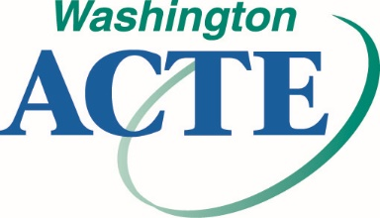

STATE OF THE SECTION REPORT

Please complete this form by September 11, 2023,
and submit electronically to Tess Alviso at: taa@wa-acte.org

Submissions will be presented at the September 23, 2023, Executive Board Zoom Meeting.

Please share with others the successes you have had in your section!

Section:

Leadership for 2023-2024

WA-ACTE Executive Board Rep:

Section President:

Section Past President:

Section President Elect:

Section Secretary:

Section Treasurer:

WA-ACTE Legislative Committee Rep:

WA-ACTE FAME Committee Rep:

WA-ACTE Professional Development Committee Rep:

Please provide a brief narrative describing current activities and strategies in the following categories:

Member Recruitment and Retention

Advocacy

Issues
(Including legislative, leadership, partnerships, business and industry, and postsecondary)

Marketing

New and Innovative Ideas

