WASHINGTON ASSOCIATION FOR  CAREER AND TECHNICAL EDUCATION  WA-ACTE  PO Box 315  Olympia WA 98507-0315  360-786-9286 | taa@wa-acte.org | www.wa-acte.org | 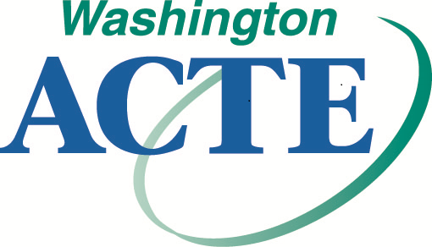 | FALL CTE CONFERENCE  Great Wolf Lodge  Grand Mound/Centralia  October 24-25, 2024 | In-Person  November 1-15, 2024 | Remote

1. CTE Section:
 WACTA – CTE Administration |  WE-BAM – Business and Marketing Education |  WAAE – Agriculture Education
 WA-CCER – Career Counseling & Employment Readiness |  WA-FACSE – Family and Consumer Sciences |  HSCTE – Health Science
 WITEA – Technology Education / STEM / Skilled and Technical Sciences

2. Name and Contact Information

Certification Number

Name (First and Last)

Badge Name (e.g. Bob for Robert)

District School

Work Address

City/State/ZIP

Work Telephone

Cell

Work Email

Personal Email

3. Fall CTE Conference Registration Registration includes approximately 12 total clock hours (pending approval) including STEM specialty clock hours; breakfast on Thursday and Friday; and lunch on Thursday (meals for in-person).

Do you have a specific dietary requirement, which requires our awareness? Please note that we strive to be an inclusive, accessible conference, but not all requests can be guaranteed. Please complete the SurveyMonkey by September 30, 2024. https://www.surveymonkey.com/r/Fall24SpRequest

* * * * Required:  In-Person  Remote * * * * | Thru September 30 | October 1-21 | After October 21
WA-ACTE Member (must have expiration date of at least 11/30/2024)  Email taa@wa-acte.org if unsure of membership status. | $375 | $425 | $475
Non-Member (or WA-ACTE renewal) | $450 | $500 | $550

4. Section / National Memberships (optional):
 $80 ACTE – National |  $35 WE-BAM – Business and Marketing Education |  $170 WAAE – Agriculture Education
 $25 WA-CCER – Career Counseling & Employment Readiness |  $25 WA-FACSE – Family and Consumer Sciences |  $20 HSCTE – Health Science
 $25 WITEA – Technology Education / STEM / Skilled and Technical Sciences
Please note: WACTA – CTE Administration must be paid through the WACTA website: https://washingtonacta.wildapricot.org/

5. Method of Payment Check/Money Order (Payable to WA-ACTE) Purchase Order #

Email for invoices:
Credit Card Payments…Online Registration Only | https://wa-acte.regfox.com/wa-acte-fall-cte-conference-2024

Policy: When your registration form is submitted you are registered for the conference whether your registration is paid for by credit card, check, or purchase order. Due to the virtual content of this conference, no cancellations will be accepted and no refunds will be given for any registration fees. In-person registration can be switched to remote or substituted by another person if unable to attend. Dues are individual, non-transferable, and non-refundable.

