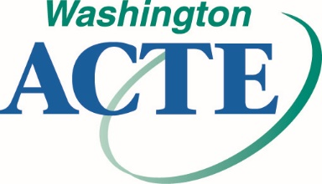

STATE OF THE SECTION REPORT

Please complete this form by September 11, 2017,
and submit electronically to Tess Alviso at: taa@wa-acte.org

Submissions will be presented at the September 16, 2017, Executive Board Inservice Meeting.

Please share with others the successes you have had in your section!

Section:
Date:

Leadership for 2017-2018

WA-ACTE Board Representative:
President:
Past President:
President Elect:
Secretary:
Treasurer:

Please provide a brief narrative describing current activities and strategies in the following categories:

Member Recruitment and Retention

Advocacy

Issues
(Including legislative, leadership, partnerships, business and industry, and postsecondary)

Marketing

New and Innovative Ideas

